HUrricane

**Project Plan**

# **Introduction**

This document specifies the organization details, key milestones, and time estimates for each phase of the HUrricane food delivery development project. It serves as a structured plan to guide the team, ensuring clarity on objectives and timelines while providing a foundation for tracking progress throughout the project’s lifecycle.

# **Project organization**

* 1. **Team**

Our team, "PentaCode," consists of five software developers—Salih Eren Yüzbaşıoğlu, Yusuf Küçüköner, Bedirhan Gençaslan, Mustafa Furkan Ateş, and Şükriye Öztürk—each contributing to the development of the food delivery system while fulfilling unique roles with specific responsibilities, as outlined in the accompanying chart.Mainly,

Salih Eren Yüzbaşıoğlu, the Software Project Manager, leads by allocating resources, setting priorities, planning schedules, managing budgets, and ensuring quality.

Yusuf Küçüköner, the Software Architect, designs high-level solutions, sets technical standards, selects tools, and troubleshoots coding issues.

Bedirhan Gençaslan, the Software Tester, verifies functionality by conducting manual and automated tests, such as unit and load testing, logging results and addressing errors.

Mustafa Furkan Ateş, the Software Analyst, connects user needs to development by analyzing the domain, defining requirements, designing solutions, and resolving business issues.

Şükriye Öztürk, the Software Configuration Manager, maintains the configuration infrastructure, ensures workspaces support development, creates the CM Plan, and tracks changes.

The team’s efforts cover key technical areas, including system design, requirement analysis, testing, and configuration management. Communication is managed through WhatsApp for seamless coordination. Collaboration with a neighboring campus services initiative provides logistical insights for delivery integration, facilitated by email and scheduled meetings.[1]

| **Team Member** | **Software Developer** | **Software Architect** | **Software Analyst** | **Software Configuration Analyst** | **Software Tester** | **Software Project Manager** |
| --- | --- | --- | --- | --- | --- | --- |
| Yusuf Küçüköner | X | X |  |  |  |  |
| Mustafa Furkan Ates | X |  | X |  |  |  |
| Şükriye Öztürk | X |  |  | X |  |  |
| Bedirhan Gençaslan | X |  |  |  | X |  |
| Salih Eren Yüzbaşıoğlu | X |  |  |  |  | X |

* 1. **Role Descriptions**
     1. **Software Project Manager**

The Software Project Manager leads the project by allocating resources, setting priorities, and coordinating with users. This role plans schedules, manages budgets, sets goals (e.g., finishing in six months), and ensures quality through defined practices.

* + 1. **Software Analyst**

The Software Analyst connects users and developers by analyzing the software domain and creating requirements. This role designs solutions, maintains systems, defines specifications, and resolves business-related issues.

* + 1. **Software Architect**

The Software Architect designs high-level solutions, sets technical standards, and selects tools. This role provides leadership, evaluates technologies, collaborates with teams, and troubleshoots coding problems.

* + 1. **Software Configuration Manager**

The Software Configuration Manager oversees the configuration infrastructure, ensuring workspaces and artifacts support development. This role creates the CM Plan and tracks changes.

* + 1. **Software Tester**

The Software Tester checks software for bugs using manual and automated tests (e.g., unit, system, load testing). This role executes tests, logs results, and fixes errors.

# **Development process and measurements**

The project will follow the Rational Unified Process (RUP), an iterative and incremental software development framework. RUP divides the project into four phases: Inception, Elaboration, Construction, and Transition. The process will be tailored to suit the project’s needs, with shorter iterations (2-3 weeks) to ensure incremental delivery and adaptability. Key activities in each phase include:

* **Inception Phase**: Define project scope, objectives, and high-level requirements. Identify stakeholders and conduct initial risk assessment.
* **Elaboration Phase**: Refine requirements, design the system architecture, and develop a detailed iteration plan.
* **Construction Phase**: Build the product incrementally through iterations, focusing on delivering functional increments.
* **Transition Phase**: Deliver the final product, address stakeholder feedback, and ensure stability.
  1. **Progress Tracking**

Weekly Review Meetings: Weekly stand-up meetings will be conducted to discuss progress, identify blockers, and plan tasks for the week. These meetings ensure alignment and keep the team on track.

Iteration Assessments: At the end of each iteration, a review meeting will be held to demonstrate completed work, gather stakeholder feedback, and adjust priorities for the next iteration. A retrospective will also be conducted to reflect on the iteration and identify areas for improvement.

Project Burndown and Iteration Burndown Reports:

Project Burndown Report: Tracks the remaining work (in points or hours) for the entire project, providing a visual representation of progress toward the project goal.

Iteration Burndown Report: Tracks the remaining work for the current iteration, helping the team stay on track to complete planned tasks by the iteration deadline.

Tools such as Jira, Trello, or Excel will be used to generate these reports.

* 1. **Measurements**

Task size and complexity will be estimated using a point system based on the Fibonacci scale (1, 2, 3, 5, 8, 13). Points reflect relative effort, complexity, and risk—for instance, a simple task might be 1 point, a moderately complex task 3 points, and a highly complex task 8 points. Team velocity, calculated as the average points completed per iteration, will be tracked to forecast future capacity and refine planning accuracy.[2]

# **Project milestones and objectives**

| **Phase** | **Iteration** | **Primary objectives** (risks and use case scenarios) | **Scheduled start or milestone** | **Target velocity** |
| --- | --- | --- | --- | --- |
| Inception | I1 | * Define the Software Vision document. * Develop the Project Plan, including timelines, milestones, and resource allocation   . | 01/03 - 14/03/2025 | 15 |
| Eloboration | E1 | * Develop the Software Requirements Document. * Define the List of System Test Case Definitions.. * Set up GitLab and establish Configuration. | 11/03 - 28/03/2025 | 16 |
| Eloboration | E2 | * Desing the Architecture of the project * Implement developer tests * Finalize architectural notebook * Create Risk Management Report. | 25/03 - 11/04/2025 |  |
| Construction | CN | * Define and adhere to a Coding Standard. * Implement the system. * Create the Design Diagram Document. * Continuously update GitLab. | 04/04 - 02/05/2025 | 26 |
| Transition | T1 | * Develop and execute Software Test Cases. * Create Software Test Report | 02/05 - 16/05/2025 |  |
| Transition | T2 | * Finalize project and deliver to GitLab. * Prepare and deliver a Presentation. * Address any remaining defects or feedback. | 09/05 - 23/05/2025 | 10 |

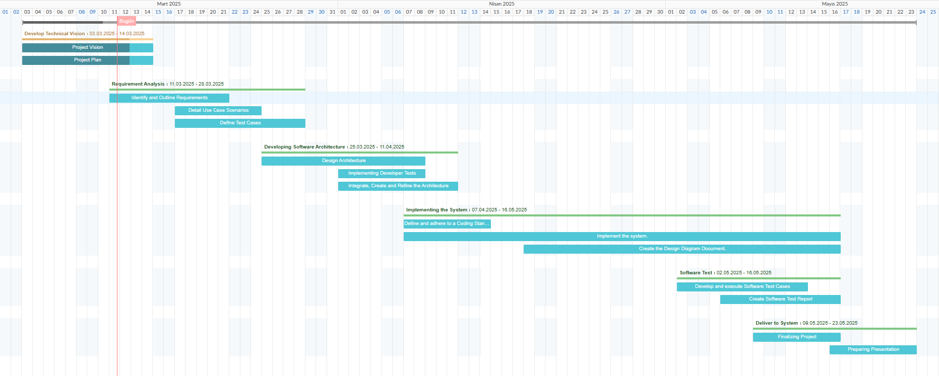

Figure, A Gantt chart demonstrating estimated schedule of project

# **Deployment**

The development of the online food delivery application will start with gathering requirements and designing the system architecture using modern technologies. The team will follow an Agile methodology, focusing on building core features, testing functionality, and ensuring a smooth user experience. After development, the application will be deployed to a staging environment on AWS or a similar cloud service for integration and user acceptance testing.

# Traceability Table

| Work/Team member | Salih Eren Yüzbaşıoğlu | Yusuf Küçüköner | Şükriye Öztürk | Bedirhan Gençaslan | Mustafa Furkan Ateş |
| --- | --- | --- | --- | --- | --- |
| Project Plan 1-2 | 3h | 1h | 3h | 1h | 0h |
| Project Plan 3-7 | 1h | 3h | 1h | 2h | 4h |
| Total effort | 4h | 4h | 4h | 3h | 4h |

# Prompts

* Grok 3 <https://grok.com/share/bGVnYWN5_805c3326-e82d-4131-878d-00f790ee0b41> groq.txt

* Deepseek [Document 24.docx](https://1drv.ms/w/c/c262c610b1d72668/Ef-KAjMomY5KrQ7OlvST2T8B7NQMGbHPf4ps2wAoZZuKSA?e=doEgcq) (No sharing so instead shared a doc which has conversation) promp2t.txt